Individual Myofibril Analyzer 1.0 (IMA)

Precise measurement of sarcomere dimensions is crucial for understanding muscle structure and function, as even minor variations can indicate underlying abnormalities or the role of a specific protein. However, current literature reveals significant inconsistencies in reported sarcomere length and width values, even within the same genetic background. This variability stems from differences in dissection protocols and measurement techniques, hindering comparisons across studies. To address this challenge and standardize sarcomere measurements, we developed a new software tool. This tool provides a uniform, streamlined and robust method for calculating sarcomere length and width from microscopic images (TIFF, LIF, CZI). Designed for automated processing, the software ideally utilizes two-channel images: one for length (optimally alpha-Actinin staining) and one for width (optimally Phalloidin staining). While it can handle images with more channels, manual selection may be required for length and/or width calculation in those cases. For Z-series the software automatically generates a sum intensity projection for histogram extraction, ensuring accurate measurements from multi-dimensional data. Single-plane images are processed directly. This tool aims to improve the consistency and comparability of sarcomere measurements across different studies, ultimately advancing our understanding of muscle biology and disease.

Requirements and installation

IMA requires Python version 3.12.8 (The application has been tested with 3.10./3.11/3.12/3.12.8). While integrated development environment (IDE) is not mandatory, it is highly recommended to use for e.g. PyCharm (or an equivalent), especially if someone is not an expert Python user. Detailed instructions for installation will be provided subsequently:

**1. Download Python**

Download a python from <https://www.python.org>. The application has been tested with 3.10./3.11/3.12/3.12.8 version of python. Don’t use python 3.13, a as some packages have not been fully optimized for it yet.

**2. Download PyCharm**

For those who are less familiar with Python, utilizing an Integrated Development Environment (IDE) like PyCharm is advisable. PyCharm can be obtained from the JetBrains website at https: //www.jetbrains.com/pycharm/. The freely available PyCharm Community Edition is sufficient for our purposes. Upon installation, PyCharm should automatically detect and configure the existing Python installation on your system.

**3. Download and open IMA as a project**

You can download the required code from the GitHub repository ( <https://github.com/GorogPeter94/Individual-Myofibril-Analyser-IMA-> ) by clicking the green Code button and selecting Download ZIP, and after extracting the files you can open the project in PyCharm by clicking Open under the File menu and selecting the extracted folder.

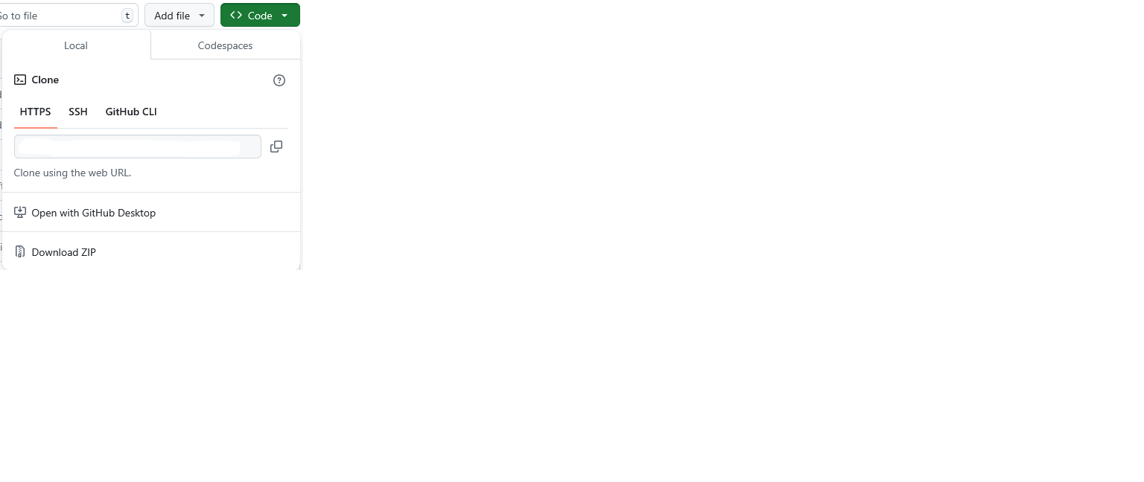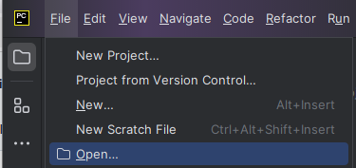

**4. Install packages**

Several packages are essential for the application's proper functionality. These can be easily installed within PyCharm. When the user opens the project, Pycharm will automaticly check a requirment.txt and offers to install the required packeges (see image below). If you choose „install requirments” than the the correct version of the packages will be automativly installed.



If it is not offered you can easly install the following packeges through the Python Packages menu (see image below), as illustrated in the image. It is mandatory to installa the correct version for each package to avoid potential errors during script execution. The required packages are as follows:

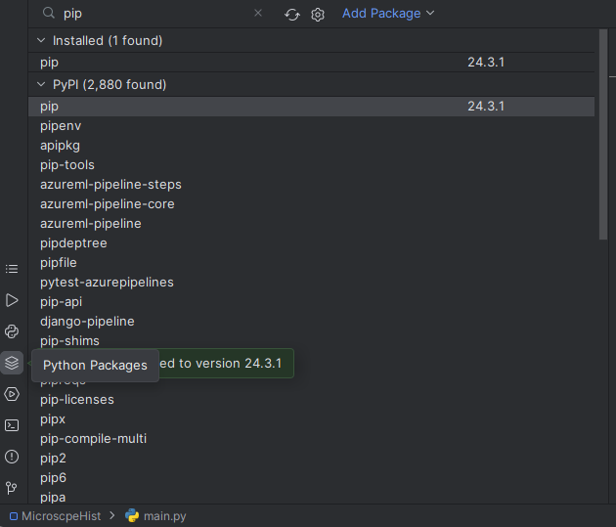

Pandas (version 2.2.3 tested)

Matplotlib (version 3.9.3 tested)

Numpy (version 2.2.0 tested)

Opencv-python (version 4.10.0.84 tested)

Aicsimageio (version 4.14 tested)

aicspylibczi (version 3.2.0 tested)

openpyxl (version 3.1.5 tested)

tifffile (version 2024.12.12 tested)

Should any difficulties arise during package installation, ensure that pip, the Python package installer, is up to date. Within PyCharm, this can be accomplished by searching for "pip" in the Python Packages menu and updating it accordingly (see the image above). Once all packages are successfully installed, the application is ready for use.

Starting the application

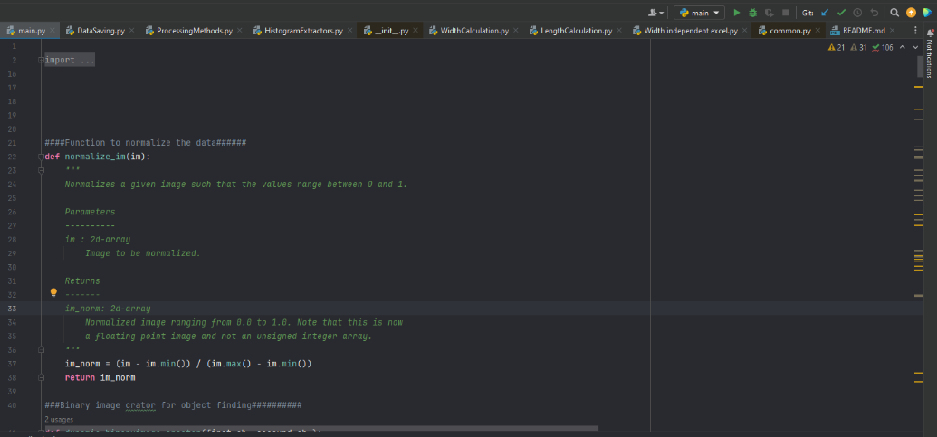Once installation is complete, initiate the application by opening and executing the main script. This can be achieved by clicking the green "play" button within the PyCharm interface. Should an error occur, it is likely due to the installation of incorrect packages or incompatible package versions.

If everything is fine, the GUI of the application should appear:

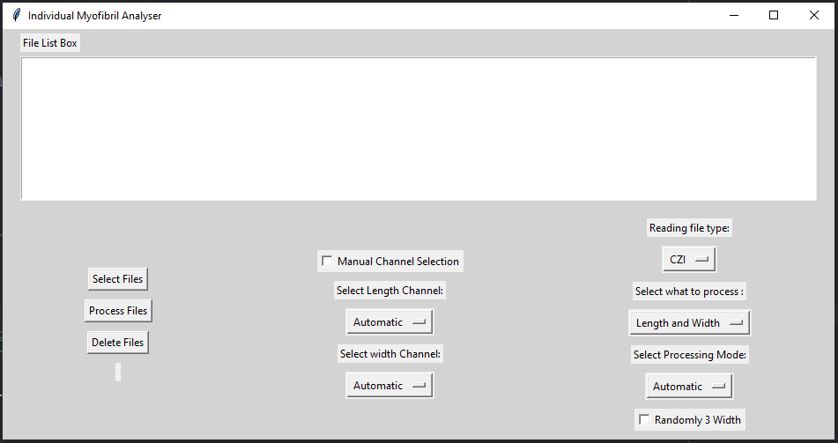

Evaluating images:

1. **File selection**

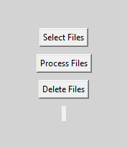Files in the supported formats (*.czi, *.tif, *.lif) can be imported through the file dialog window, accessed by clicking the **Select file** button.

Imported files will populate the **File List Box**. To remove a specific file, select it and click "**Delete Files**". To clear the entire list, click "**Delete Files**" without selecting any file. This will remove all entries from the **File List Box**.

1. **Setting up the parameters:**

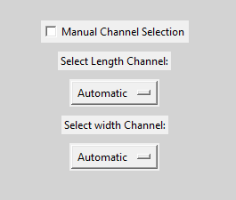**Channel Selection**: Channel selection can be performed automatically, when the "**Manual Channel Selection Box**" is unchecked, or manually, when the "**Manual Channel Selection Box**" is checked.

**Automatic channel** selection is suitable for images containing only two channels, one designated for length calculation and the other for width calculation. This mode operates under the assumption that the Phalloidin channel, typically used for width calculation, encompasses a larger area within the image as compared to the α-Actinin/Zasp channel, which is preferred for length calculation.

For images with more than two channels or those utilizing alternative staining methods, manual channel selection is necessary. Activate this mode by checking the designated box and then specify the appropriate channels for length and width calculations, respectively.

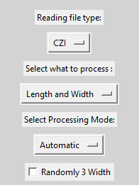**Selecting Reading file type**: The application offers two distinct file readers. While the default reader is optimized for Czi files, an alternative reader is available for TIFF and LIF file formats.

**Select what to process**: You have the flexibility to specify the scope of the analysis. The application allows for the evaluation of sarcomere length exclusively, or the assessment of both width and length of the sarcomeres.

**Select Processing Mode**: Automatic, Semi-manual and manual modes are available.

***Automatic mode:***

Length: separate the channels → create a binary image from the max Z projection of the images → find the centroid of every α-actinin signal → connect the middle points of every signal with spline in order → extract the histogram along the line with 10-pixel averaging → find and fit a Gaussian function for every peak in the histogram → extract the middle point coordinates of every peak and calculate the length of the sarcomeres

Width: In a pop-up window the user can select which sarcomere to evaluate (if the “**Random 3 Width**” is checked then 3 points will be randomly selected) → the software will calculate the perpendicular line from the angle of the spline at the selected point → extract the histogram along the line with 10-pixel averaging → fit them with a “disk function” to produce precise diameter estimates

***Semi-manual mode:***

While the underlying process for length evaluation remains consistent with the automatic mode, the semi-manual mode allows users to specify the order of the identified centroids. This feature provides flexibility and control, particularly in scenarios where the automatic ordering may be inaccurate or ambiguous. Detailed instructions for utilizing this functionality can be found in section 4, "Semi-manual and Manual Mode."

***Manual mode:***

In manual mode, the user holds complete control over centroid placement. An interactive pop-up window displays the length channel, allowing the user to manually create and position central points. These points then serve as the basis for both length and width calculations, following the same procedures as in the automatic mode.

Important Considerations for Manual Mode:

Accurate Placement: Ensure that the manually placed points accurately represent the centers of the desired structures (e.g., Z-discs for length calculation).

Endpoint Positioning: The first and last points should be positioned outside the first and last Z-discs, respectively. This prevents the histogram from starting or ending mid-way through a Z-disc, ensuring accurate representation of the intensity profile.

Refer to section 4, "Semi-manual and Manual Mode," for detailed instructions on utilizing this manual mode effectively. This mode offers maximum user control and flexibility, particularly for complex or ambiguous images where automated detection may be challenging.

1. **Starting the evaluation**

Initiate the evaluation process by clicking the "**Process Files**" button. This action triggers the analysis of the files present in the **File List Box**, according to the settings. Selecting specific files in the list will restrict the evaluation to those chosen files. Conversely, if no files are selected, the process will evaluate all files within the File List Box.

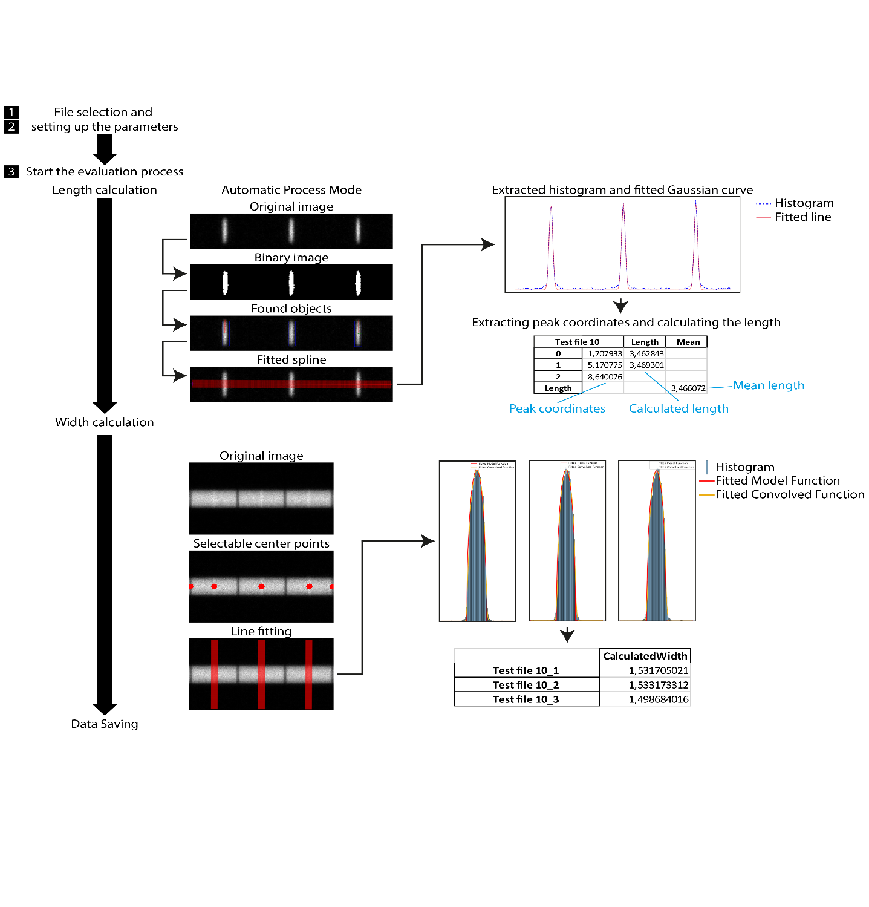

The basic steps of the automatic mode

1. **Semi-manual and manual mode:**

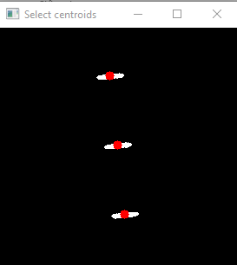**Semi-manual**: In this mode, the application automates the initial step of identifying the centers of the objects (e.g., Z-discs). However, it requires user intervention to determine the correct order of these points. Once the order is finalized, the application proceeds with the automated steps of spline creation, histogram extraction, Gaussian fitting and length calculation, as described previously.

A typical example:

Centroid Selection: The user is presented with an interactive window displaying the identified centroids (see the image).

Ordering: The user must click on each centroid in the desired order using the **left mouse** button. As each point is selected, its color changes to blue, providing visual feedback. This order is crucial as it dictates the path of the spline that will be generated to connect the points.

Correction: If an error is made in the selection order, the user can undo the last selection by **right-clicking** within the "Select centroids" window.

Important Note: In semi-manual mode, width calculation is always performed manually. The points created during the length calculation phase are presented as selectable points for the subsequent width calculation. This allows for precise user control over both length and width measurements.

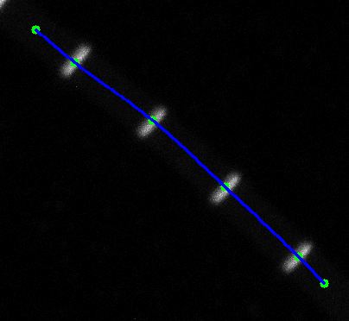**Manual**: Manual mode offers maximum flexibility for sarcomere analysis. This mode is particularly useful when the automated and semi-manual modes are unsuitable due to challenging image conditions, such as high background signal.

A typical example for this mode:

Interactive Window: A pop-up window displays the selected length channel, allowing for direct user interaction.

Centroid Creation: The user manually creates central points (represented in green) within the window using the left mouse button. At least four points are required for proper spline generation.

Spline Visualization: The software generates a spline curve (in blue) connecting the created points, visually outlining the path for length measurement.

Length and Width Calculation: After length calculation using the user-defined spline, the same points are used as selectable points for the subsequent width calculation.

Centroid Creation Controls:

Left Click: Creates a new point.

Right Click: Deletes the nearest existing point.

Middle Click (Hold and Drag): Allows for precise repositioning of an existing point.

1. **Extra function during the evaluation:**

**Automatic length calculation checkpoint**: To ensure accurate length measurements, the automated length calculation process includes a checkpoint that identifies potential outliers in the dataset. These outliers might arise from the presence of multiple myofibrils in the image or if the Otsu's thresholding method inadvertently includes extraneous signals. If an outlier is detected, the application immediately switches to a semi-manual mode. This prompts the user to manually select the desired centroid points for accurate length determination, ensuring reliable results despite the initial automated outlier detection. In situations where the automatic length calculation encounters an outlier and switches to semi-manual mode, the width calculation will always default to manual mode as well. This approach promotes consistency and provides users with the ability to review and adjust the length and width measurements, ensuring accuracy in cases where the automated process may detect potential discrepancies.

**Mode changing**:

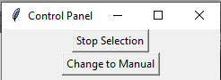In semi-manual mode, a Control Panel is available, which allows the user to switch to manual mode for the specific image being analyzed, even if the initial mode selection was semi-manual.

This feature is particularly useful when certain images within a dataset require more user intervention due to challenging image characteristics or unexpected artifacts. It allows for a tailored approach to analysis, ensuring accurate and reliable results across diverse image conditions.

1. **Data saving**

During the evaluation process, the application diligently documents the analysis by generating two image files for each input microscopy image. These images correspond to the length and width results, respectively, providing a visual representation of the analysis. At the end of every evaluation step the application saves all generated histograms and calculated data into a comprehensive Excel spreadsheet. This organized output facilitates convenient data management, subsequent analysis, and seamless integration with other research workflows.

Length image:

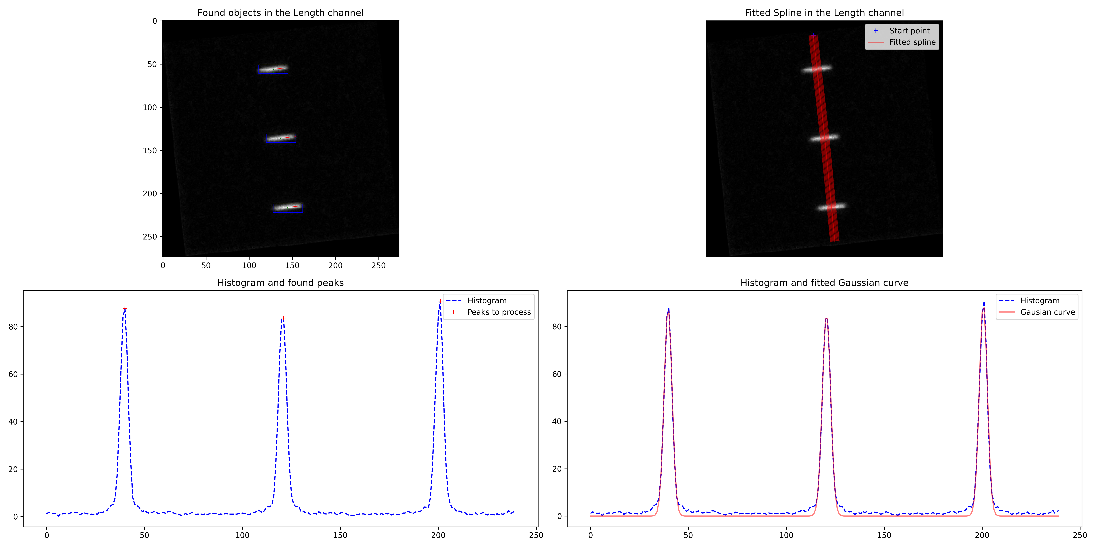

The ‘length image’ describes the visual output generated by the application for each analyzed image, providing a comprehensive overview of the sarcomere length analysis process: **Upper Left Image**: Displays the raw length channel image with the identified central points (e.g., Z-discs) marked. This allows users to visually assess the accuracy of the automated or manual point selection. **Upper Right Image**: Shows the 10-pixel wide spline curve that connects the central points. This illustrates the path along which the intensity profile is extracted for length calculation. **Bottom Left Image**: It displays the 10-pixel averaged histogram derived from the intensity profile along the spline. Importantly, it highlights the peaks identified by the peak finder algorithm, marking them with crosses. This visualization allows users to quickly assess the accuracy of peak detection, a crucial step in determining sarcomere length. **Bottom Right Image**: Depicts the same histogram with the fitted Gaussian curves overlaid on each peak. This visualization demonstrates how the software precisely determines the center of each peak for accurate length calculation.

Width image:

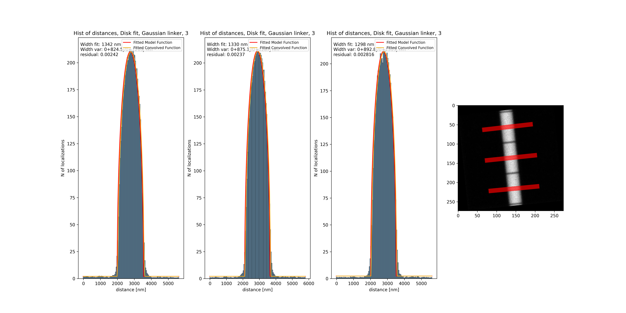

The ‘width image’ describes the visual output generated by the application for width analysis: **Right Side**: Displays the width channel image with a 10-pixel wide line passing through the user-selected or automatically-identified centroids. This line represents the path along which the intensity profile is extracted for width calculation. **Left Side**: Shows the corresponding histogram of the intensity profile along the line, along with the fitted model function for each selected point.